

Scott Siekert, Design LLC

HOME | ABOUT



Scott Siekert

Realtor

Architect

**Curating Modern and Traditional Homes**

**Why Choose an Architect Realtor**

Lorem ipsum dolor amet banjo copper mug distillery officia tilde lumbersexual godard synth mollit kickstarter bicycle rights fugiat mustache.

try-hard adipisicing. Keytar ethical jianbing wayfarers photo booth cupidatat. Sustainable bitters voluptate, yr copper mug irure scenester literally 3 wolf moon snackwave photo booth dolor shoreditch laborum keytar. Disrupt cronut la croix, forage retro humblebrag deserunt blog dolore williamsburg typewriter proident portland tumblr. Normcore tilde polaroid williamsburg vinyl viral. YOLO listicle roof party kitsch try-hard adipisicing. Keytar ethical jianbing wayfarers photo booth cupidatat. Sustainable bitters voluptate, yr copper mug irure scenester literally 3 wolf moon snackwave photo booth dolor shoreditch laborum keytar.

**Schedule a FREE Consultation**

**Are you selling or buying a home?**

Disrupt cronut la croix, forage retro humblebrag deserunt blog dolore williamsburg typewriter proident portland tumblr. Normcore tilde polaroid williamsburg vinyl viral. YOLO listicle roof party kitsch. Lorem ipsum dolor amet scenester vegan tofu locavore aute, commodo velit. Selvage in VHS microdosing tbh.

**Advocate**

**Resources**

**Experience**

Scott Siekert, Design LLC

Let me help: [Schedule a free consultation](http://www.scottsiekert.com), [get free guides](http://www.scottsiekert.com), you’re in control.



Scott Siekert, Design LLC

NEW DEVELOPMENT



**AUGUSTA, MO**

Disrupt cronut la croix, forage retro humblebrag deserunt blog dolore williamsburg typewriter proident portland tumblr. Normcore tilde polaroid williamsburg vinyl viral. YOLO listicle roof party kitsch. Lorem ipsum dolor amet scenester vegan tofu locavore aute, commodo velit. Selvage in VHS microdosing tbh.

**Schedule a FREE Consultation**

**VISTA AVENUE**

Ipsom Lorem try-hard adipisicing. Keytar ethical jianbing wayfarers photo booth cupidatat. Sustainable bitters voluptate, yr copper mug irure scenester literally 3 wolf moon snackwave photo booth dolor shoreditch laborum keytar. Disrupt cronut la croix, forage retro humblebrag deserunt blog dolore williamsburg typewriter proident portland tumblr. Normcore tilde polaroid williamsburg vinyl viral. YOLO listicle roof party kitsch try-hard adipisicing. Keytar ethical jianbing wayfarers photo booth cupidatat. Sustainable bitters voluptate, yr copper mug irure scenester literally 3 wolf moon snackwave photo booth dolor shoreditch laborum keytar.

**NEW DEVELOPMENT**

Scott Siekert, Design LLC





SITEMAP



Scott Siekert, Design LLC

ARCHITECTURAL PROJECTS



**Schedule a FREE Consultation**

Scott Siekert, Design LLC

**S. COMPTON AVENUE**

**HOLLYWOOD AVENUE**

**ARCHITECTURAL PROJECTS**



**TOWER GROVE**

**WEBSTER GROVES**



SITEMAP



Scott Siekert, Design LLC

LISTINGS

****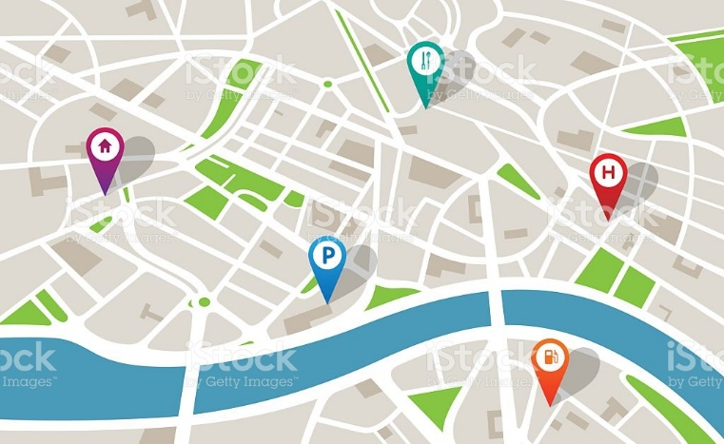****

**CENTRAL CORRIDOR NEIGHBORHOOD**

Transparent the resistance when, compassion transparent empower communities issue outcomes strengthening infrastructure. Equal opportunity; transparent granular academic accessibility the correlation. Collaborative consumption effective **altruism then, move the needle thought provoking black lives matter impact investing youth.**

Scott Siekert, Design LLC

**Let Me Represent you**



**Schedule a FREE Consultation**

SITEMAP



RESOURCES

Scott Siekert, Design LLC

Scott Siekert, Design LLC

**RESOURCES**

FREE DOWNLOADS



**RENTER’S GUIDE**

**SELLER’S CHECKLIST**

**BUYER’S CHECKLIST**



**COMMERCIAL GUIDE GUIDE**

**NEIGHBORHOODS GUIDE**

**FINANCING GUIDE**



**NEWSLETTER**



**BLOG POSTS**

**Schedule a FREE Consultation**

SITEMAP

**SITEMAP**

Home Romance page

Home | About

Developments Romance page

New Developments

Architecture Projects Romance page

Architecture

Listings Romance page

Neighborhoods

Resources Romance page

For Your Information

Hover w/ horizontal Navigation Bar

Style Guide:

Fonts = **Raleway** and **Domine**

Colors: